## Project Idea | Smart Waste Management System For Metropolitan Cities

Smart Waste Management System For Metropolitan Cities

RADHI SHREE A P / REENA JOHANNA P/ ROSHINI A S / SHIVANIKA K

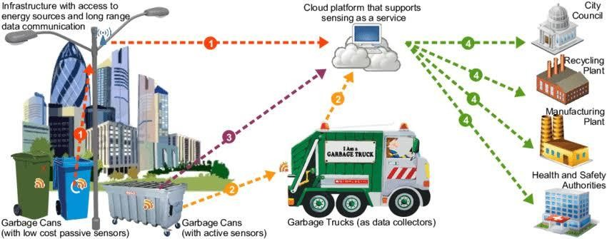

* **NOTE:**

# Software Required:

Python IDLE

# System Required:

* RAM-Minimum 4GB Processor-Min. Configuration OS-Windows/Linux/MAC
* Garbage level detection in bins.
* Getting the weight of the garbage in the bin.
* Alerts the authorized person to empty the bin whenever the bins are full.
* Garbage level of the bins can be monitored through a web App.
* We can view the location of every bin in the web application by sending GPS location from the device.

# Technical Architecture:

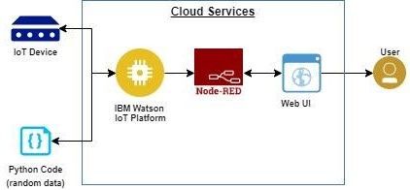

INTRODUCTION:

The Internet of Things (IoT) is a concept in which surrounding objects are connected through wired and wireless networks without user intervention. In the field of IoT, the objects communicate and exchange information to provide advanced intelligent services for users.

This project deals with the problem of waste management in smart cities, where the garbage collection system is not optimized. This project enables the organizations to meet their needs of smart garbage management systems. This system allows the user to know the fill level of each garbage bin in a locality or city at all times, to give a cost-effective and time-saving route to the truck drivers.

# OBJECTIVES

The key research objectives are as follows:

* The proposed system would be able to automate the solid waste monitoring process and management of the overall collection process using IOT (Internet of Things).
* The Proposed system consists of main subsystems namely Smart Trash System(STS) and Smart Monitoring and Controlling Hut(SMCH).
* In the proposed system, whenever the waste bin gets filled this is acknowledged by placing the circuit at the waste bin, which transmits it to the receiver at the desired place in the area or spot.
* In the proposed system, the received signal indicates the waste bin status at the monitoring and controlling system.

# PRODUCT FEATURES

With the web application, the administrator will be able to search for dustbins. The result will be based on the criteria the user inputs. There are several search criteria, and it will be possible for the administrator of the system to manage the options for those criteria that have that.

The result of the search will be viewed either in a list view or in a map view, depending on what criteria are included in the search. The list view will have one list item for each dustbin matching the search criteria and show a small part of the dustbin information, so the user can identify the dustbin. The administrator will be able to either select a dustbin as a target destination or get information on how to get there or view the information of a specific dustbin.

The web portal will provide the functionality to manage the system and the dustbin information. It will also provide information about the system, for example, showing when there is a new update.

## A list of possible stakeholders of the system and a brief description of their needs, business rules, possibilities and connections with others is presented below:

* City administration needs an understanding of the big picture, generating reports, control over pricing etc.
* District administrations are interested in controlling the process of waste collection, checking the quality of service (all waste collected, all in time, waste collected cleanly, waste transported to special places), quick and legal ways for solving disputes and problems.
* Municipalities can also deploy and maintain smart city infrastructure like capacity sensors in waste bins and wireless networks for data transferring.
* Waste trucks owning companies need a platform for organizing and optimization of their business process in general without serious investments in developing, deploying and supporting their own system. Such a system must include effective dynamic routing based on IOT data for the truck fleet. Besides, controlling drivers and tracking the fleet is also an important issue.
* Waste truck drivers need a navigation system for fulfilling their tasks. Another issue is reporting problems and passing them to the operators in the office instead of thinking about how to solve the problem, this can sufficiently save the time of a driver and vehicle. Drivers also need evidence that their work was done correctly and cleanly.
* Managers of dumps and recycling factories can publish their possibilities or needs in acquiring a certain amount of waste for storing or recycling.
* Staff that is responsible for trash bins in the current yards needs communications with waste management companies and truck drivers.
* Road police can get reports about inaccurate car parking that leads to the impossibility of waste collection. • Citizens want to have better service, lower cost and having easily accessible reports on what has been done and how much it cost

# HARDWARE INTERFACE:

## Arduino Uno

Arduino Uno is a microcontroller board. It has 14 digital input/ output pins (of which 6 can be used as PWM outputs), 6 analogue inputs, a 16 MHz quartz crystal, a USB connection, a power jack, an ICSP header and a reset button. It contains everything needed to support the microcontroller; simply connect it to a computer with a USB cable or power it with an AC-to-DC adapter or battery to get started.. You can tinker with your UNO without worrying too much about doing something wrong, in the worst case scenario you can replace the chip for a few dollars and start over again.

## Ultrasonic Sensor:

The Ultrasonic Sensor sends out a high-frequency sound pulse and then times how long it takes for the echo of the sound to reflect back. The sensor has 2 openings on its front. One opening transmits ultrasonic waves, (like a tiny speaker), the other receives them, (like a tiny microphone). The speed of sound is approximately 341 meters (1100 feet) per second in air. The ultrasonic sensor uses this information along with the time difference between sending and receiving the sound pulse to determine the distance to an object.

## Wi-Fi Module – ESP8266:

The ESP8266 WiFi Module is a self-contained SOC with an integrated TCP/IP protocol stack that can give any microcontroller access to your WiFi network. The ESP8266 is capable of either hosting an application or offloading all Wi-Fi networking functions from another application processor. Each ESP8266 module comes pre-programmed with an AT command set firmware, meaning, you can simply hook this up to your Arduino device and get about as much WiFi-ability as a WiFi Shield offers. ? Breadboard: A breadboard is a construction base for prototyping of electronics. In the 1970s the solderless breadboard (AKA plugboard, a terminal array board) became available and nowadays the term “breadboard” is commonly used to refer to these.

“Breadboard” is also a synonym for “prototype”. Because the solderless breadboard does not require soldering, it is reusable. This makes it easy to use for creating temporary prototypes and experimenting with circuit design. ? JUMPER WIRES: A jump wire is an electrical wire or group of them in a cable with a connector or pins at each end (or sometimes without them – simply “tinned”), which is normally used to interconnect the components of a breadboard or other prototype or test circuit, internally or with other equipment or components, without soldering.

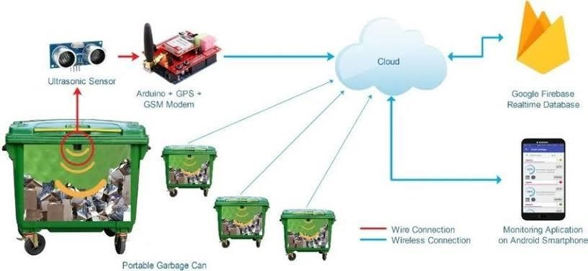

# SOFTWARE INTERFACE:

## Arduino IDE:

The open-source Arduino Software (IDE) makes it easy to write code and upload it to the board. It runs on Windows, Mac OS X, and Linux. The environment is written in Java and based on Processing and other open-source software. This software can be used with any Arduino board. It contains a text editor for writing code, a message area, a text console, a toolbar with buttons for common functions and a series of menus.

## Web Server:

A Web server is a program that uses Hypertext Transfer Protocol to serve the files that form Web pages to users, in response to their requests, which are forwarded by their computers’ HTTP clients. Dedicated computers and appliances may be referred to as Web servers as well.

Front end Technologies:

## HTML5:

HTML5 is a markup language used for structuring and presenting content on the World Wide Web. It is the latest and most enhanced version of HTML.

## CSS3:

Cascading Style Sheets (CSS) is a style sheet language used for describing the look and formatting of a document written in a markup language.CSS3 is the latest standard of CSS.

## Javascript:

JavaScript is a full-fledged dynamic programming language that, when applied to an HTML document, can provide dynamic interactivity on websites.

## JQuery:

JQuery is a cross-platform JavaScript library designed to simplify the client-side scripting of HTML. JQuery is the most popular JavaScript library in use today.

Back end Technologies:

## PHP:

PHP is a server scripting language and a powerful tool for making dynamic and interactive Web pages.

## MySql:

MySQL is an open-source relational database management system (RDBMS). It is very fast, reliable, and easy to use.

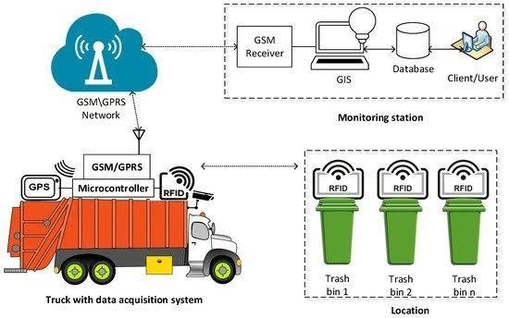

# Application

The project design is a part of the implication that can be used to improve the waste management of a locality. All the technical aspects have been thoroughly designed keeping all the constraints in mind. The project resolves around whether the project will be able to meet the future needs of the users. This project-based on IoT gives users the freedom of changing hardware as well as software specifications as per the arising need. IoT based projects are already designed while keeping future demands in mind and in a rising economy like India where the concept of smart cities is new the demand for our project will keep on increasing. This project here is a model of the large scale application which spans pan India in different smart cities. The implementation of this project has been divided into various phases. Starting from the metropolitan cities and moving towards the

concept of smart cities, it will also cover small towns and tier III cities in later phases. At present, we are here to display the live working of the model and give an idea about the actual implications. For any society to flourish, it is manifestly important that they remain fair and orderly. Deciding how best to ensure this, in light of the huge growth in both the uptake and complexity of technology that has occurred in the last decade, and which can be expected to continue in the next, this here is one of the products that can be used to contribute to the better management of waste and increase the efficiency of resources.